Internship weekly report

Week 2 (October 27, 2014 - November 1, 2014)

This week I started recreate the [premium Joomla template](http://livedemo00.template-help.com/wt_51882/index.html) called Orphan Care using Yoo theme master.

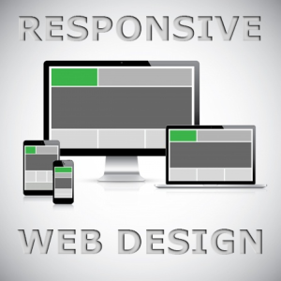

The Orphan Care Joomla Template is a Responsive Website using a [Responsive web design](http://en.wikipedia.org/wiki/Responsive_web_design). I have received a tutorial how to make the theme responsive.

Almost all Epion websites are responsive and I have to make the template.

I think am ready to start commercial development on Joomla. I got a good experience working with Joomla.

# Addis Tena Higher clinic

I started a website for Epion client **Addis Tena Higher Clinic** located at [http://www.addistena.com](http://www.addistena.com/). Currently their website is the worst site imaginable.



The Addis Tena website took me more time of this week and now I am waiting for last comment from my supervisor.

|  |  |
| --- | --- |
| Technical things I learned this week | |
| Responsive web design | * is one of the hottest topics among designers and developers right now. * term is related to the concept of developing a website design in a manner that helps the layout to get changed according to the user’s computer screen resolution * The basic instinct might be to choose media queries to develop a responsive site. |
| Media Query | * By using the @media rule, a website can have a different layout for screen, print, mobile phone, tablet, etc. * are incredibly useful because they solve a huge problem that arose quite suddenly in web design: the need to design for vastly different screen sizes. |